 | QUESTIONNAIRE  For Calorifier Selection

Supplier and Manufacturer: | Customer Details:
OPEKS Energysystems | Company:
01042, Kyiv, P.O. Box 111, Ukraine | Tel:
Tel: +38 044 536 11 90 | e-mail:
https://opeks.ua | Contact Person:
e-mail: office@opeks.ua | Position

Please complete the initial data in the table below:
Designation |  |  | Unit
Service (specify: air heating / air cooling)
Heat load |  |  | kW
CIRCUIT I (heat carrier)
Heat carrier (specify: water, steam, freon)
Flow rate (if heat output data is unavailable) |  |  | kg/h
Heat carrier temperature | at the calorifier inlet |  | °C
Heat carrier temperature | at the calorifier outlet |  | °C
Heat carrier temperature | Freon boiling temperature |  | °C
Heat carrier temperature | Steam saturation temperature |  | °C
Heat carrier operating pressure |  |  | bar
Maximum operating temperature |  |  | °C
Maximum operating pressure |  |  | bar
Refrigerant |  |  | R
CONTOUR II (air)
Air flow rate |  |  |  | Nm³/h
Air temperature |  | at the calorifier inlet |  | °C
 |  | at the calorifier outlet |  | °C
Material (carbon steel of standard quality,
stainless steel, copper–aluminium)

Overall dimensions of the calorifier:

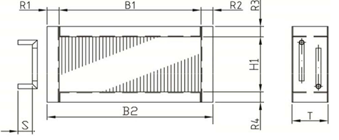

B1 | B2 | H1 | S | T | R1 | R2 | R3 | R4

